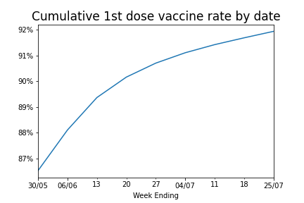

Data source: <https://lginform.local.gov.uk/>.

Description: A cumulative proportion of registered residents of England who have received one dose of a COVID-19 vaccine. Figures only include vaccinations recorded between the 8th of December 2020 and the most recent date displayed above. 2020 Mid-year population data from the ONS was used here. Please note this total is the sum of the number of people vaccinated in each age group. As there were a small number of individuals with an unknown age this figure may slightly underestimate the number of people vaccinated. Overall, weekly vaccination rates are slowing as we reach saturation and a certain asymptote. What is the value of this asymptote, and does it differ between age groups?

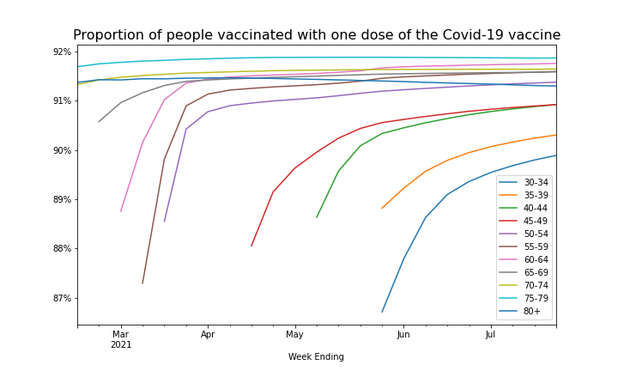Data source: <https://lginform.local.gov.uk/>.

Description: A cumulative proportion of registered residents of England who have received one dose of a COVID-19 vaccine divided by age group. Figures only include vaccinations recorded between the 8th of December 2020 and the most recent date displayed above. 2020 Mid-year population data from the ONS was used here. As there were a small number of individuals with an unknown age this figure may slightly underestimate the number of people vaccinated. Every age group’s weekly vaccination rate is slowing as we reach saturation and a certain asymptote. However, this asymptote does appear to differ between age groups.

Note that the data starts at different dates because the data started on different dates when the data was accessed. Additionally notice that the data for 75-79 and 80+ appears to decrease as time goes on. This was unexpected and is likely due to no utilisation of death data or use of a fixed population value from mid-2020.

Below is a chart showing the varying asymptote (or “tailing off”) values between age groups. The “tailing off” value here is when the weekly cumulative vaccination rates in England drop and stay below 0.95% of the population, for each age group. Please note that although this “tailing off” measure is being used to explore vaccine hesitancy, it does not necessarily represent the proportion of people who are unwilling to have the vaccine. It also includes people ineligible for or have not been offered the vaccine.

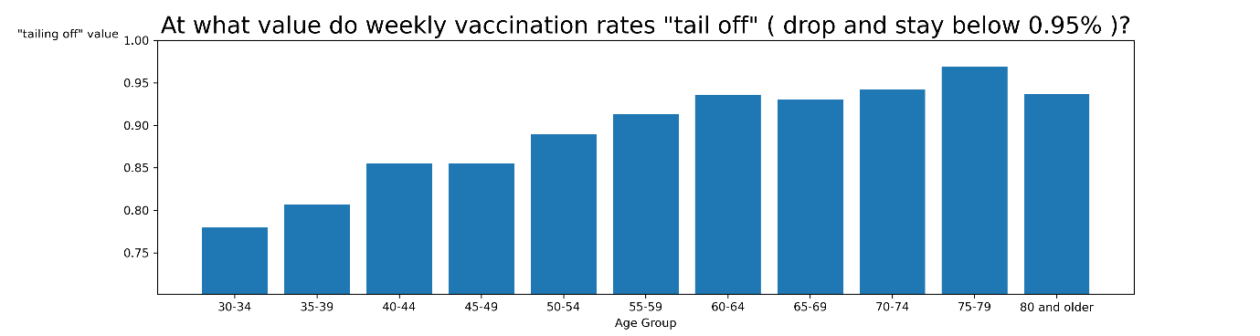

From this chart we can see that the younger age groups have a smaller “tailing off” value. These results seem to suggest that vaccine hesitancy is worse amongst lower age groups. Reasons for this hesitancy could be apathy towards getting the vaccine or perceived risk from COVID-19 compared to perceived risks of side-effects from the vaccine, in younger age groups. Under 25s- and 25–29-year-olds will be added in the future. See if we can find data from as early as February or December.

Data source: <https://lginform.local.gov.uk/>.

# Description: The above graphs explore vaccine hesitancy compared to IMD metrics within the local authorities of England. The *hesitancy measure* represents the value at which the cumulative weekly vaccine rates drop and stay below 1.5% of the total population of the area. Figures only include vaccinations recorded from the 8th of December 2020. 2020 Mid-year population data from the ONS was used here. IMD data was taken from, ‘English indices of deprivation 2019’. From the *LGInform* website, ‘IMD - Overall - extent (%) - The main IMD summary measure. It is a weighted average of the seven IMD domains: Income Deprivation, Employment Deprivation, Health Deprivation and Disability, Education Skills and Training Deprivation, Barriers to Housing and Services, Living Environment Deprivation, and Crime. Extent is a local authority level measure which represents the proportion of an authority's population living in the most deprived LSOAs in the country. This is a weighted measure of the population in the most deprived 30 per cent of all areas: the population living in the most deprived 10 per cent of LSOAs in England receive a 'weight' of 1.0; the population living in the most deprived 11 to 30 per cent of LSOAs receive a sliding weight, ranging from 0.95 for those in the eleventh percentile, to 0.05 for those in the thirtieth percentile.’ Similarly, each of the seven individual IMD metric is calculated using, ‘a local authority level measure which represents the proportion of an authority's LSOAs that fall in the most deprived 10% of LSOAs nationally.’ Both these measures were chosen to be able to analyse the data at a local authority level.

# Below are two charts showing the Pearson’s Correlation Coefficient of the IMD metrics compared with *Cumulative 1st doses per 100k* and *hesitancy measure* when dividing the data by local authority. My initial assumption was that vaccine hesitancy would be more strongly correlated to Education than say Crime. But these results show that Crime is the IMD metric that is most related to vaccine uptake whereas Education is much further down the list. Further analysis and validity is required here.

